VERIFICATION AND VALIDATION OF SIMULATION MODELS
One of the most important and difficult tasks facing a model developer is the verification and validation of the simulation model.
• It is the job of the model developer to work closely with the end users throughout the period (development and validation) to reduce this uncertainty (skepticism) and to increase the credibility.
The goal of the validation process is two fold
1. To produce a model that represents true system behavior closely enough for the model to be used as a substitute for the actual system for the purpose of experimenting with system.
2. To increase an acceptable, level the credibility of the model, so that the model will be used by managers and other decision makers.
The verification and validation process consists of the following component
Verification: It is concerned with building the model right. It is utilized in comparison of the conceptual model to the computer representation that implements that conception. It asks the questions: Is the model implemented correctly in the computer? Are the input parameters and logical structure of the model correctly represented?
Validation: It is concerned with building the right model. It is utilized to determine that a model is an accurate representation of the real system. It is usually achieved through the calibration of the model.
Model Building, Verification and Validation
• The first step in model building consists of observing the real system and the interactions among its various components and collecting data on its behavior. Operators, technicians, repair and maintenance personnel, engineers, supervisors and managers under certain aspects of the system which may be unfamiliar to others. As model development proceeds, new questions may arise and the model developers will return, to this step of learning true system structure and behavior.
• The second step in model building is the construction of a conceptual model – a collection of assumptions on the components and the structure of the system, plus hypotheses on the values of model input parameters, illustrated by the following figure-5.1.

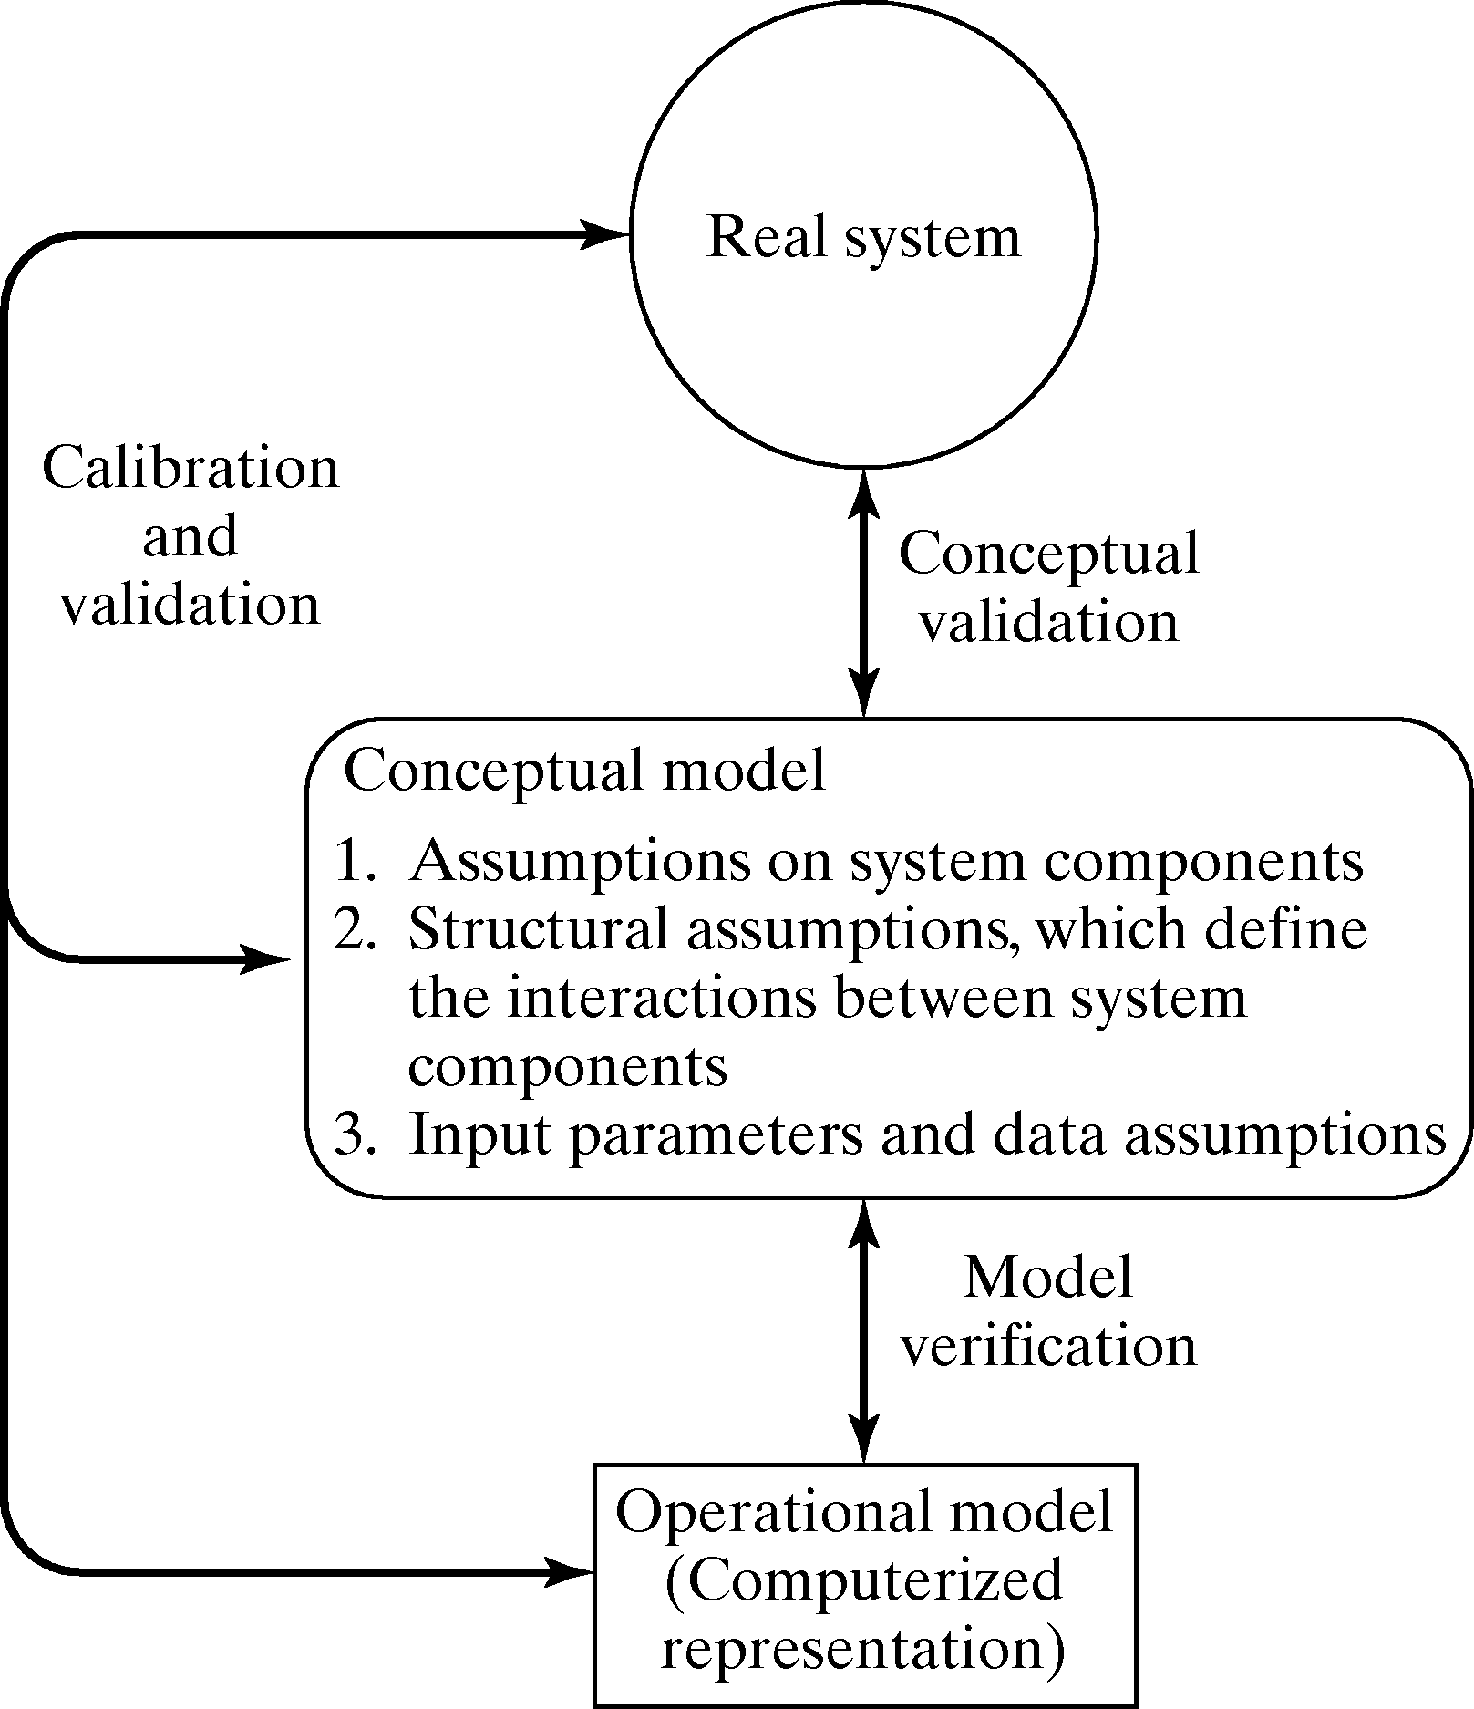
Figure-5.1: Model building, Verification and Validation

The third step is the translation of the operational model into a computer recognizable form the computerized model.
Verification of Simulation Models
The purpose of model verification is to assure that the conceptual model is reflected accurately in the computerized representation.
The conceptual model quite often involves some degree of abstraction about system operations or some amount of simplification of actual operations.
Suggestions in the verification process:
1. Have the computerized representation checked by someone other than its developer.
2. Make a flow diagram which includes each logically possible action a system can take when an event occurs, and follow the model logic for each action for each event type.
3. Closely examine the model output for reasonableness under a variety of settings of Input parameters.
4. Have the computerized representation print the input parameters at the end of the Simulation to be sure that these parameter values have not been changed inadvertently.
5. Make the computerized representation of self-documenting as possible.
6. If the computerized representation is animated, verify that what is seen in the animation imitates the actual system.
7. The interactive run controller (IRC) or debugger is an essential component of Successful simulation model building. Even the best of simulation analysts makes mistakes or commits logical errors when building a model. The IRC assists in finding and correcting those errors in the following ways:
a) The simulation can be monitored as it progresses.
b) Attention can be focused on a particular line of logic or multiple lines of logic that constitute a procedure or a particular entity.
c) Values of selected model components can be observed. When the simulation has paused, the current value or status of variables, attributes, queues, resources, counters, etc., can be observed.
d) The simulation can be temporarily suspended or paused, not only to view information but also to reassign values or redirect entities.
8. Graphical interfaces are recommended for accomplishing verification & validation.

Calibration and Validation of Models

Verification and validation although are conceptually distinct, usually are conducted simultaneously and interactively by the modeler. Validation is the overall process of comparing the model and its behavior to the real system and its behavior. Calibration is the iterative process of comparing the model to the real system, making adjustments to the model, comparing again and so on.
The following Figure-5.2 shows the relationship of the model calibration to the overall validation process. The comparison of the model to reality is carried out by variety of test. Test is subjective and objective. Subjective test usually involve people, who are knowledgeable about one or more aspects of the system, making judgments about the model and its output. Objective tests always require data on the system's behavior plus the corresponding data produced by the model.

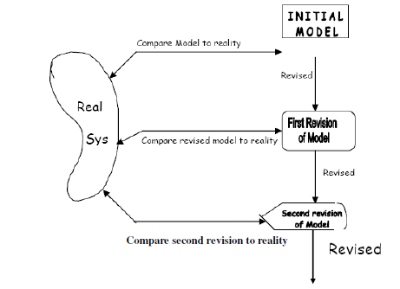

Figure-5.2: Iterative Process of Calibration model

A possible criticism of the calibration phase, were it to stop at point, ie., the model has been validated only for the one data set used; that is, the model has been "fit" to one data set.
Validation is not an either/or proposition—no model is ever totally representative of the system under study. In addition, each revision of the model, as in the Figure above involves some cost, time, and effort.
As an aid in the validation process, Naylor and Finger [1967] formulated a three step approach which has been widely followed:-
1. Build a model that has high face validity.
2. Validate model assumptions.
3. Compare the model input-output transformations to corresponding input-output transformations for the real system.
FACE VALIDITY
• The first goal of the simulation modeler is to construct a model that appears reasonable on its face to model users and others who are knowledgeable about the real system being simulated.
• The users of a model should be involved in model construction from its conceptualization to its implementation to ensure that a high degree of realism is built into the model through reasonable assumptions regarding system structure, and reliable data.
• Another advantage of user involvement is the increase in the models perceived validity or credibility without which manager will not be willing to trust simulation results as the basis for decision making.
• Sensitivity analysis can also be used to check model's face validity.
• The model user is asked if the model behaves in the expected way when one or more input variables are changed.
• Based on experience and observations on the real system the model user and model builder would probably have some notion at least of the direction of change in model output when an input variable is increased or decreased.
• The model builder must attempt to choose the most critical input variables for testing if it is too expensive or time consuming to: vary all input variables.
Validation of Model Assumptions
Model assumptions fall into two general classes: structural assumptions and data assumptions:
Structural assumptions involve questions of how the system operates and usually involve simplification and abstractions of reality.
For example, consider the customer queuing and service facility in a bank. Customers may form one line, or there may be an individual line for each teller. If there are many lines, customers may be served strictly on a first-come, first-served basis, or some customers may change lines if one is moving faster.
The number of tellers may be fixed or variable. These structural assumptions should be verified by actual observation during appropriate time periods together with discussions with managers and tellers regarding bank policies and actual implementation of these policies.
Data assumptions should be based on the collection of reliable data and correct statistical analysis of the data.
Data were collected on:
1. Inter arrival times of customers during several 2-hour periods of peak loading
("rush-hour" traffic)
2. Inter arrival times during a slack period
3. Service times for commercial accounts
4. Service times for personal accounts.
The procedure for analyzing input data consist of three steps:
1. Identifying the appropriate probability distribution.
2. Estimating the parameters of the hypothesized distribution.
3. Validating the assumed statistical model by goodness – of – fit test such as the Chi-square test, K-S test and by graphical methods.

Validating Input-Output Transformation:
• In this phase of validation process the model is viewed as input –output transformation.
• That is, the model accepts the values of input parameters and transforms these inputs into output measure of performance. It is this correspondence that is being validated.
• Instead of validating the model input-output transformation by predicting the future, the modeler may use past historical data which has been served for validation purposes that is, if one set has been used to develop calibrate the model, its recommended that a separate data test be used as final validation test.
• Thus accurate “prediction of the past” may replace prediction of the future for purpose of validating the future.
• A necessary condition for input-output transformation is that some version of the system under study exists so that the system data under at least one set of input condition can be collected to compare to model prediction.
• If the system is in planning stage and no system operating data can be collected, complete input-output validation is not possible.
• Validation increases modeler’s confidence that the model of existing system is accurate.
• Changes in the computerized representation of the system, ranging from relatively minor to relatively major include.
1. Minor changes of single numerical parameters such as speed of the machine, arrival rate of the customer etc.
2. Minor changes of the form of a statistical distribution such as distribution of service time or a time to failure of a machine.
3. Major changes in the logical structure of a subsystem such as change in queue discipline for waiting-line model, or a change in the scheduling rule for a job shop model.
4. Major changes involving a different design for the new system such as computerized inventory control system replacing a non computerized system.
If the change to the computerized representation of the system is minor such as in items one or two these change can be carefully verified and output from new model can be accepted with considerable confidence.
Partial validation of substantial model changes in item three and four may be possible.

Input-Output Validation: Using Historical Input Data
When using artificially generated data as input data the modeler expects the model produce event patterns that are compatible with, but not identical to, the event patterns that occurred in the real system during the period of data collection.
• Thus, in the bank model, artificial input data {X_{1n}, X_{2n}, n = 1,2, , .} for inter arrival and service times were generated and replicates of the output data Y2 were compared to what was observed in the real system
- An alternative to generating input data is to use the actual historical record, {A_{n}, S_{n},
n = 1,2,...}, to drive simulation model and then to compare model output to system data.
• To implement this technique for the bank model, the data A1, A2,..., S1 S2 would have to be entered into the model into arrays, or stored on a file to be read as the need arose.
• To conduct a validation test using historical input data, it is important that all input data (A_{n}, S_{n},...) and all the system response data, such as average delay(Z₂), be collected during the same time period.
• Otherwise, comparison of model responses to system responses, such as the comparison of average delay in the model (Y₂) to that in the system (Z₂), could be misleading.
• Responses (Y₂ and Z₂) depend on the inputs (A_{n} and S_{n}) as well as on the structure of the system, or model.
• Implementation of this technique could be difficult for a large system because of the need for simultaneous data collection of all input variables and those response variables of primary interest.
Input-Output Validation: Using a Turing Test
In addition to statistical tests, or when no statistical test is readily applicable persons knowledgeable about system behavior can be used to compare model output to system output.
For example, suppose that five reports of system performance over five different days are prepared, and simulation output is used to produce five "fake" reports. The 10 reports should all be in exactly in the same format and should contain information of the type that manager and engineer have previously seen on the system.
• The ten reports are randomly shuffled and given to the engineers, who are asked to decide which reports are fake and which are real.
• If engineer identifies substantial number of fake reports the model builder questions the engineer and uses the information gained to improve the model.
• If the engineer cannot distinguish between fake and real reports with any consistency, the modeler will conclude that this test provides no evidence of model inadequacy. This type of validation test is called as TURING TEST.

